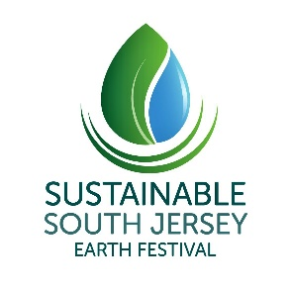
2019 Sustainable South Jersey Earth Festival @ Cherry Hill
Sponsorship Opportunities
Hello:
We invite you to join as a sponsor of the 10th anniversary
Sustainable South Jersey Earth Festival at historic Croft Farm – on Saturday, May 4, 2019 .
Sponsor this event and show your green leadership. You’ll be on display in prime locations among more than 100 earth-friendly vendors, educational and non-profit groups, and two stages of entertainment. Our event also includes the Family Fun Bike Ride, bike valet parking, healthy food options, plus recycling and composting.
More than 5,000 people from Cherry Hill and surrounding communities attend; Under our new name, our reach is across South Jersey as Cherry Hill Township and school district collaborate with us throughout the planning season. With your sponsorship, your organization will shine as a supporter of our mission: “Driving Sustainability in South Jersey to benefit our collective future.”
Custom Earth Festival sponsorships – and festival activity sponsorships are available. (Examples: bike ride, healthy food court, school displays.)
Plus - Sustaining Sponsorships available: Show your year-round support; Platinum and Gold level sponsorships, provide year-long sponsorship of all Sustainable South Jersey and some partner events. Your organization may cross-promote events with emphasis on your organization’s sustainability mission and goals through SSJ’s web site, social media, and e-blasts. (Please see Sustaining Sponsor document outlining this program and benefits.) Sustaining sponsors are a “presenting sponsor” for the Earth Festival.
Celebrate – Learn – Grow
Sustainable South Jersey Earth Festival is a family and earth-friendly event designed
to educate, inspire and promote sustainable, healthy living.
Presented by Sustainable South Jersey (501c3);
Supported by Cherry Hill Township and Cherry Hill Public Schools.
DEADLINE – February 28, 2019– To receive maximum pre-festival exposure
Earth Festival Sponsorship Levels and Benefits | Presenting  $2500 | Leadership  $1500 | Green  $750 | Leaf  $500
- Top-level display; “Presented by” in all festival & bike ride print and social media outreach
- Large logo (linked where possible) and priority placement in festival materials including Web site, social media, email blasts
- Medium logo in most festival materials & web site
- Event-day signage and sponsor announcements during event
- Your one-time, 200-word sustainable message (subject to editing) posted online and social media to our hundreds of supporters scheduled before the festival. Due by 3/15/19
- 2-3 sentence description of your Festival display or your organization’s sustainability mission (if provided) – posted on social media platforms and festival materials
- Social media mentions of your participation
- Festival event prime location – approx. 10’x20’
- Festival event space - 10’x10’ – front of festival site
- Please email the Earth Festival sponsorship application below and attach ONE high resolution organization logo (jpeg only) to brenda@brendajorett.com
- 10’x10’ space only provided; please bring table, tent/canopy, chairs, tent banner, weights to secure display materials
- Event day set-up guidelines are sent mid-April: Festival set-up 7:30 a.m. – 9:30 a.m. Event is rain or shine.
- Composting of food & recycling available on site; please, NO disposable, plastic water bottles for giveaway, sale, or use.
Earth Festival Requirements:
- All items for display, sale, or giveaway, including crafts, apparel, and decorative items, must be representative of the sustainable theme and mission of the festival. Items should be at least made in USA and from recycled or reused sources where possible. Please provide a full description of your product(s) or service on sign-up form. (Note: we discourage sale or give-away of
non-recycled plastic items made overseas.)
2. In keeping with our sustainable theme, please do not use or give out: plastic bags, Styrofoam or polystyrene, helium balloons, six-pack rings or anything that can be harmful to wildlife or human life. We ask that you lead by example and encourage use of recycled products and consider using a reusable water bottle at the event.
3. Please provide environmentally-friendly packaging. Please ask (rather than assume) if visitors need an item bagged or wrapped, and if so, please try to use paper.
4. NO portable generators permitted; limited electricity access is available upon request; as space allows.
5. In the event of violation of the agreed terms on the signed application, Earth Festival organizers and producer reserve the right to request immediate removal of said merchandise and/or display with no refund provided or obligation of any kind.

On behalf of the Sustainable South Jersey board, and our team of volunteers, thank you for supporting Sustainable South Jersey and our many outreach efforts to educate and support sustainability throughout the South Jersey region and beyond.

Please reach out with questions or special requests you may have about the Earth Festival, sponsorship, and Sustaining Sponsorship of Sustainable South Jersey.

We look forward to another outstanding Earth Festival and Family Fun Bike Ride – rain or shine - Saturday, May 4, 2019 at Croft Farm, Cherry Hill.

Best regards,
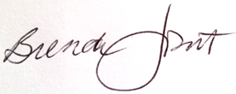
Brenda Jorett
Producer – Sustainable South Jersey Earth Festival @ Cherry Hill
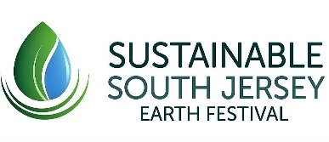 @SSJEarthFest
Owner-Consultant
PR and Content Strategies

Enc. SSJ EF application

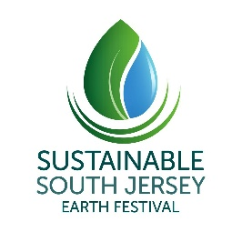
10th Sustainable South Jersey Festival – Sat., May 4, 2019
2019 SPONSORSHIP APPLICATION – Due by Feb. 28, 2019
Please complete all information requested below. Sponsorship proceeds benefit education, scholarship, grant, and outreach programs for Sustainable South Jersey, a 501c3 non-profit organization.
Check requested sponsorship level:
- Sustaining SSJ sponsor- one-year, all-event sponsorship 󠆼Platinum $7500 󠆼Gold $5000
Earth Festival only:
Presenting $2,500 Leadership $1,500 Green $750 Leaf $500 Other (please contact Brenda Jorett for details
- In-Kind (product/service must be equal-to or greater than $100)
- Check if Earth Festival POWER requested; Power must be confirmed April 1. NO generators.
*While we complete our formal name change, please make sponsorship checks payable to Sustainable Cherry Hill. Thank you.
Please print clearly and mail hard copy to address below or type, scan, and email with high-resolution jpeg of company logo to brenda@brendajorett.com
Name of Company/Organization:
Contact Name/Title:
Contact: office cell Event day cell
Company Address:
City: State: Zip:
Contact Email (for notification):
Back-up Contact name/cell/email:
Company web site address
Facebook page address: Twitter handle:
Event Day Sponsor Details – please relay event-day information to all staff; car-pooling encouraged- limited parking at Croft Farm.
How many people will staff your display area at the Earth Festival?
Event day contact name if different from above: _______________Cell #_________________
Does your company require display power on event day? Yes _____No ____(No generators permitted)
Kindly detail below how your display coordinates with community sustainability and the Earth Festival.
Please consider: No plastic water or drink bottles. Limit foreign-made plastic items for give-away.

The representative of the above-named sponsor has read and understood event requirements and sponsorship benefits and will disseminate information to other company participants in this event. Sustainable South Jersey retains the right to decline a request to participate. Participation does not constitute endorsement by Sustainable South Jersey, event co-hosts or other sponsors. Please read important event guidelines and distribute to event-day participants from your company.

Please sign: (sponsor/company representative): ________Date________________
Kindly make sponsorship checks payable to: Event & sponsorship questions:
Sustainable Cherry Hill (legal entity TFN) Brenda Jorett, Event Producer
RE: 2019 Earth Festival brenda@brendajorett.com
c/o Robert Blatt, Treasurer 856-448-2205
168 Barclay Farm Shopping Center #133, Cherry Hill, NJ 08034
Financial questions: treasurer@sustainablecherryhill.org

